INTRODUCTION

1.INTRODUCTION

1.1 OBJECTIVE:

The Online Tutor Pupil is web application software being designed and developed to meet the needs of Students and Trainers so as to map and engage the classes as required. Using this web application, the real time scenario of the searching process of trainers / students can be made easier. This will help the Students to get the right persons’ guidance in their academic prospects.

Major Modules:

- Admin
- Tutor
- Pupil

Functionalities of Modules:

Admin can perform the following operations:
- View / Update / Search of Pupil / Tutor / Feedback
- Rating of Tutors based on Feedback
- Preparation of mapping summary

Pupil have the following privileges:
- Obtaining membership
- Navigating the Tutor Gallery
- Adding the requirement
- Payment through credit card
- Feedback on Tutors
- Changing password

Tutors have the following privileges:
- Obtaining membership
- Navigating the Students List
- Adding the requirement
- Changing password

1.2 OUTLINE AND BRIEF DESCRIPTION OF THE ISSUE INVOLVED

The administrator has the full privilege in this web application. The user with admin login can add / approve / decline / remove tutors / pupil records. The Tutors’ availability information can be updated from time to time. Also, on regular basis admin keeps checking the new request from pupil and map the same. The dispatch service module is also taken care by admin according to the availability of Tutor.

The Pupil will have to register to avail training session through our web application. Only the authentic Pupil can make request on sessions required. The authenticity of Tutor / Pupil are maintained through user name and password. Tutor / Pupil are facilitated with password change, they can register new password if their password is compromised. The Pupils have options to view the availing list of Tutors on the subjects they want to get trained.. The credit card module included in this application is little challenging and tedious operation.

SYSTEM REQUIREMENT ANALYSIS
2. SOFTWARE REQUIREMENT ANALYSIS

System Analysis is a detailed study of the various operations performed by a system and their relationships within and outside of the system. Analysis begins when a developer begins a study of the program using existing system. During analysis, data are collected on the various files, decision points and transactions handled by the present system. The commonly used tools in the system are Data Flow Diagram, interviews, etc. Training, experience and common sense are required for collection of relevant information needed for the development of the system. The success of the system depends largely on how clearly the problem is defined, thoroughly investigated and properly carried out through the choice of solution. A good analysis model should provide not only the mechanisms of problem understanding but also the frame work of the solution. Thus it should be studied thoroughly by collecting data about the system. Then the proposed system should be analyzed thoroughly in accordance with the needs.

2.1 PRESENT SYSTEM

The existing system is functionally compatible with the process logic, but lacking in certain operations both at the Tutors and Pupils side that must be included in the system for the changing business models. The mapping module and the service tracking are not automated. Usually the e-commerce websites does not provide with the order tracking. The Pupils will have to register for the same with customer support team and make phone calls to know the system. In this type of order tracking the Pupils face lots of hardships in getting connected and to talk to the executive for knowing the status.

2.2 PROPOSED SYSTEM

In the proposed system, the drawbacks of existing system are overcome. The Pupil support for order tracking is done through one of the web module, so that customers can track the order status through the web pages. The numerous phone calls and endless waiting is eliminated. All other operations are typical web commerce oriented, so system functionality is well understood. The development and usage of this application is really interesting one.

SYSTEM REQUIREMENT SPECIFICATION

3. SOFTWARE REQUIREMENT SPECIFICATION

A software requirements specification (SRS) is a comprehensive description of the intended purpose and environment for software under development. The SRS fully describes what the software will do and how it will be expected to perform.
An SRS minimizes the time and effort required by developers to achieve desired goals and also minimizes the development cost. A good SRS defines how an application will interact with system hardware, other programs and human users in a wide variety of real-world situations. Parameters such as operating speed, response time, availability, portability, maintainability, footprint, security and speed of recovery from adverse events are evaluated.
The requirements of this web application (OnlineTutorPupil) developed by us is very well understood and documented initially when the process started. Accordingly the hardware and software requirements are chosen. The same can be referred in the next section of this report. This web application runs in the Apache Tomcat Server, which can be accessed by web clients through the Internet from anywhere in the world. The SRS parameters are adopted in this system, with the detailed feasibility study. While developing, this system tested as the localhost, through the Mozilla firefox browser. Also, few other popular web browsers are tested.

H/W AND S/W CONFIGURATION

4. SOFTWARE AND HARDWARE CONFIGURATION

HARDWARE
Processor | Intel Core i3
RAM | 2GB
HDD | 500GB
SOFTWARE
CLIENT SIDE TECHNOLOGIES | XHTML, CSS, JAVASCRIPT
SERVER SIDE TECHNOLOGIES | SERVLET, JSP, BEANS, JDBC
WEB SERVER | APACHE TOMCAT 7.0
IDE | NETBEANS 7.0.1
TEST TOOL | JUnit
BUILD TOOL | ANT
WEB AUTHORING TOOLS | PHOTOSHOP, FLASH

SOFTWARE PROFILE

5. SOFTWARE PROFILE

5.1 ABOUT HTML/XHTML

HTML (Hyper Text Markup Language):
HTML was created by Tim Berners-Lee at European Laboratory for Particle Physics (CERN) in late 1980’s. Developed by the World Wide Web Consortium; HTML or the Hyper Text Markup Language, as its name suggests, is a markup language for Web pages. Today, the most important component of any web page is the text-based information that it contains. The markup tags of HTML define the structure of the text-based information of a web page. HTML tags are used to denote various text-based information of a webpage as paragraphs, headings, links, bullet points etc. Various HTML tags can also be used to supplement the text with images, forms and other objects. HTML tags are for browsing; they are meant for interactions between humans and computers.

Hardware Interface:

Client side:

- Processor: Intel Core i3.
- RAM: 2GB.
- Network Interface.

Server Side:

- Processor: Intel Core i3.
- RAM: 2GB.
- Disk space: 2GB.

Software Interface

Client side:

- Windows XP/ Vista/ Win 7.
- Internet Explorer 6.0 or above
- Network Interface.

Server Side:

- Apache Tomcat Web Server 7.0.1.
- Oracle 10g Database as Back End.
- J2EE Framework.

HTML draft version timeline

October 1991
HTML Tags an informal CERN document listing eighteen HTML tags, was first mentioned in public.

June 1992
First informal draft of the HTML DTD with seven subsequent revisions (July 15, August 6, August 18, November 17, November 19, November 20, November 22)

November 1992
HTML DTD 1.1 (the first with a version number, based on RCS revisions, which start with 1.1 rather than 1.0), an informal draft.

June 1993
Hypertext Markup Language was published by the IETF IIIR Working Group as an Internet-Draft (a rough proposal for a standard). It was replaced by a second version one month later, followed by six further drafts published by IETF itself that finally led to HTML 2.0 in RFC1866

November 1993
HTML+ was published by the IETF as an Internet-Draft and was a competing proposal to the Hypertext Markup Language draft. It expired in May 1994.

April 1995 (authored March 1995)
HTML 3.0 was proposed as a standard to the IETF, but the proposal expired five months later without further action. It included many of the capabilities that were in Raggett's HTML+ proposal, such as support for tables, text flow around figures and the display of

January 2008

HTML5 was published as a Working Draft by the W3C.
Although its syntax closely resembles that of SGML, HTML5 has abandoned any attempt to be an SGML application and has explicitly defined its own "html" serialization, in addition to an alternative XML-based XHTML5 serialization.

Characteristics: -

- It is the language which can be easily understood and can be modified.
- Effective presentations can be made with the HTML with the help of its all formatting tags.
- It provides the more flexible way to deign web pages along with the text.
- Links can also be added to the web pages so it helps the readers to browse the information of their interest.
- You can display HTML documents on any platforms such as Macintosh, Windows and Linux etc.
- Graphics,videos and sounds can also be added to the web pages which give an extra attractive look to your web pages. Allows database integration with wide variety of applications.
- Additional internet capabilities.

XHTML Versions: -
XHTML is a separate language that began as a reformulation of HTML 4.01 using XML 1.0. It continues to be developed:
- XHTML 1.0, published January 26, 2000, as a W3C Recommendation, later revised and republished August 1, 2002. XHTML 1.1 published May 31, 2001, as a W3C Recommendation. It is based on XHTML 1.0 Strict, is reformulated using modules from Modularization of XHTML, which was published April 10, 2001, as a W3C Recommendation.
- XHTML 2.0 There is no XHTML 2.0 standard. XHTML 2.0 is only a draft document and it is inappropriate to cite this document as other than work in progress. XHTML 2.0 is incompatible with XHTML 1.x and, therefore, would be more accurately characterized as an XHTML-inspired new language than an update to XHTML 1.x.
- XHTML5, which is an update to XHTML 1.x, is being defined alongside HTML5 in the HTML5 draft.

5.2 JAVA SERVER PAGES (JSP)
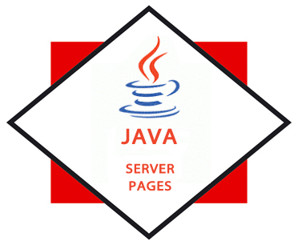

Released in 1999 by Sun Microsystems, JavaServer Pages (JSP) is similar to ASP and PHP, but it uses the Java programming language. JavaServer Pages (JSP) is a technology that helps software developers serve dynamically generated web pages based on HTML, XML, or other document types.

JSP allows Java code and certain pre-defined actions to be interleaved with static web markup content, with the resulting page being compiled and executed on the server to deliver an HTML or XML document. The compiled pages and any dependent Java libraries use Java bytecode rather than a native software format, and must therefore be executed within a Java virtual machine (JVM) that integrates with the host operating system to provide an abstract platform-neutral environment.

JSP syntax is a fluid mix of two basic content forms: scriptlet elements and markup. Markup is typically standard HTML or XML, while scriptlet elements are delimited blocks of Java code which may be intermixed with the markup. When the page is requested the Java code is executed and its output is added, in situ, with the surrounding markup to create the final page. JSPs must be compiled to Java bytecode classes before they can be executed, but such compilation is needed only when a change to the source JSP file has occurred.
Characteristics of Java Server Pages

- The Power of Server-Side Java
- Easy and Rapid Web Development, Deployment and Maintenance
- Emphasizing Reusable Components
- Separating Content Generation from Presentation
- Open Development and Widespread Industry Support
- Platform Independence

5.3 SERVLET



A Servlet is a Java programming language class that is used to extend the capabilities of servers that host applications access via a request-response programming model. Although servlets can respond to any type of request, they are commonly used to extend the applications hosted by web servers. For such applications, Java Servlet is a Java class in Java EE that conforms to the Java Servlet API, a protocol by which a Java class may respond to requests. They are not tied to a specific client-server protocol, but are most often used with the HTTP protocol. Therefore, the word "Servlet" is often used in the meaning of "HTTP Servlet".[2] Thus, a software developer may use a servlet to add dynamic content to a Web server using the Java platform. The generated content is commonly HTML, but may be other data such as XML. Servlets are the Java counterpart to non-Java dynamic Web content technologies such as CGI and ASP.NET. Servlets can maintain state in session variables across many server transactions by using HTTP cookies, or URL rewriting.
Characteristics Of Java Servlet

- Servlets are efficient

- Servlets are robust

- Servlets are portable.

- Servlets are persistence.

5.4 APACHE TOMCAT

Apache Tomcat is an open source software implementation of the Java Servlet and JavaServer Pages technologies. The Java Servlet and JavaServer Pages specifications are developed under the Java Community Process.
Apache Tomcat is developed in an open and participatory environment and released under the Apache License Version 2. Apache Tomcat is intended to be a collaboration of the best-of-breed developers from around the world. Apache Tomcat powers numerous large-scale, mission-critical web applications across a diverse range of industries and organizations. Apache Tomcat, Tomcat, Apache, the Apache feather, and the Apache Tomcat project logo are trademarks of the Apache Software Foundation.
Apache Tomcat (or simply Tomcat, formerly also Jakarta Tomcat) is an open source web server which means that it is free and is managed by a large team of volunteers, a process that efficiently and effectively maintains the system and servlet container developed by the Apache Software Foundation (ASF).
Tomcat implements the Java Servlet and the JavaServer Pages (JSP)
Specifications from Oracle Corporation, and provides a "pure Java"
HTTP web server environment for Java code to run.

Apache is available for a range of operating systemS including UNIX,
LINUX, WINDOWS, SOLARIS, NOVELL NETWARE, MAC OS X.

5.5 ORACLE



The Oracle Database (commonly referred to as Oracle RDBMS or simply as Oracle) is an object-relational database management system (ORDBMS)] produced and marketed by Oracle Corporation. The original version of Oracle was developed by Software Development Laboratories (SDL) in 1977.

An Oracle database system is identified by an alphanumeric system identifier or SID, which comprises of at least one instance of the application, along with data storage. The Oracle DBMS can store and execute stored procedures and functions within it.
Storage: -

The Oracle RDBMS stores data logically in the form of tablespaces and physically in the form of data files. Tablespaces can contain various types of memory segments, such as Data Segments, Index Segments, etc. Segments in turn comprise one or more extents. Extents comprise groups of contiguous data blocks. These data blocks form the basic units of data storage.
Database Schema: -

Oracle database conventions refer to defined groups of object ownership (generally associated with a "username") as schemas. Most Oracle database installations traditionally come with a default schema called SCOTT. The name of the SCOTT schema originated from Bruce Scott, one of the first employees at Oracle (then Software Development Laboratories), who had a cat named Tiger. Oracle Corporation has de-emphasized the use of the SCOTT schema, as it uses few of the features of the more recent releases of Oracle. Most recent examples supplied by Oracle Corporation reference the default HR or OE schemas. Other default schemas include SYS, SYSTEM, OUTLN, BI, IX, HR, OE, PM, and SH.
5.6 DATABASE MANAGEMENT SYSTEM

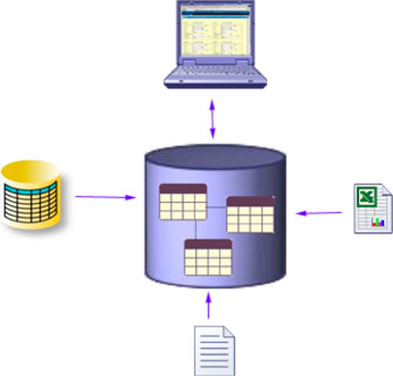

A database management system (DBMS) is a collection of programs that enables users to create and maintain a database. This is a software system that allows access to the data contained in the database. The primary goal of a DBMS is to provide an environment that is both convenient and efficient to use in storing and retrieving database information.

Functions of DBMS:-

DBMS is a general purpose software system that performs the following functions:-

- Defining a database.
- Constructing the database.
- Manipulating the database.
- Sharing database among various users.
- Protecting the database.
- Maintaining a database.

DBMS Architecture:-

DBMS architecture consists of three levels known as Three Schema Architecture. It is convenient tool with which the user can visualize the schema levels in a database system. It contains of the following three schemas:-

- The Internal level: - This contains of an internal schema, which describes the physical storage structure of the database. It is the lowest level of abstraction. It does not hide the storage details. It contains the definition of the stored record, the method of representing the data fields and the access aids used. This internal schema uses a physical data model and describes the complete details of data storage and access paths for the database. It is also called the physical schema.
- The Conceptual level: - This has a conceptual schema, which describes the structures of a database for a group of users. This schema hides the storage details from the user and it includes description of entities, data types, relationships, user operations and constraints. The description of data at this level is in a format independent of its physical representation.
- The External level: - This has a number of external schemas or user views. Each external schema describes the part of the database that a particular user group is interested in and hides all the other details from this group. This is at a highest level of database absorption.
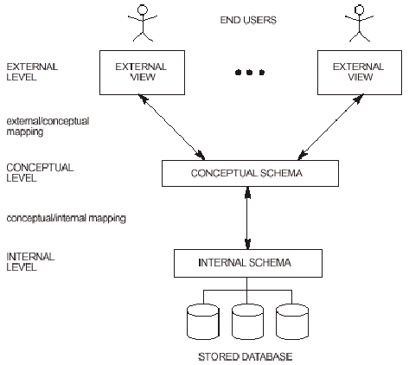
Fig: - Three schema DBMS architecture

Client-Server Architecture: -

The client/server architecture was developed to deal with computing environments in which a large number of PCs, workstations, file servers, printers, database servers, Web servers and other equipment are connected via a network. There are two client/server architecture:-
- Two-tier
- Three-tier
- N-tier

Two-Tier Client/Server Architecture: -

In two tier architecture, the software components are distributed over two systems: the client and the server. This architecture has two forms as: logical two-tier and physical two-tier.

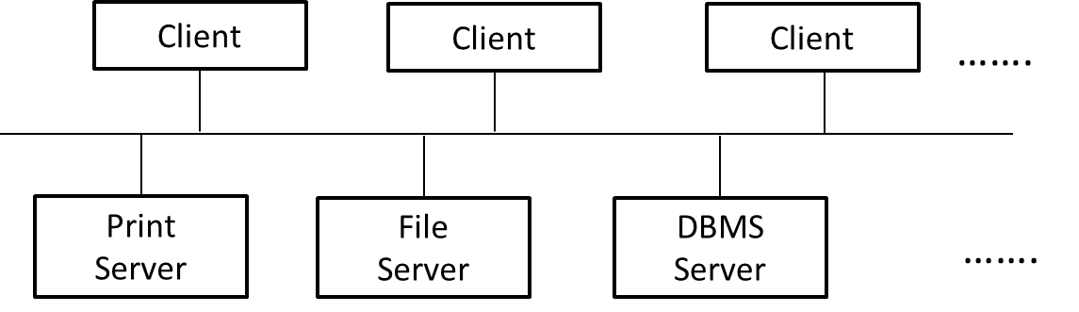

Fig: - Logical two-tier client/server architecture

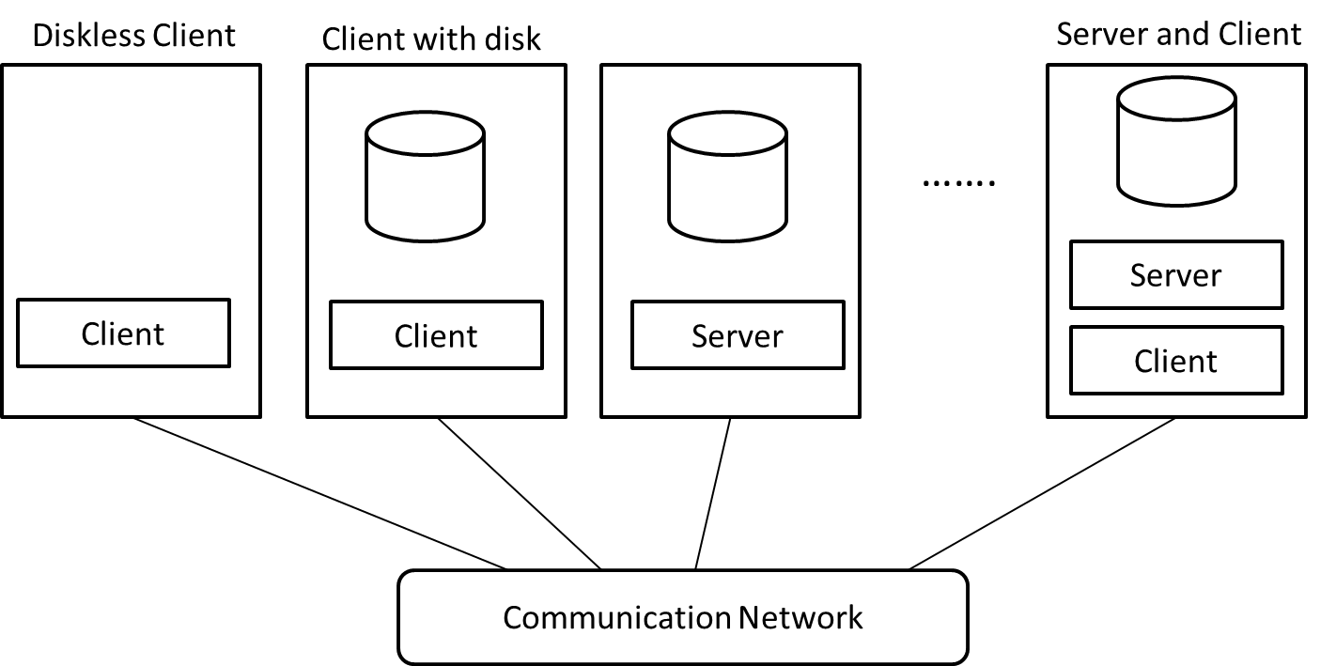
Fig: - Physical two-tier client/server architecture

The above figure shows the physical client/server architecture. Some machines like diskless workstations, or workstations/PCs with disks that have only client software installed would be only client sites. The query and transactions functionality are included on the server side. A client program can send query and transaction requests using the ODBC API which are then processed at the server site. The query results are sending back to the client program which can process or display the results needed.

Three-Tier Client/Server Architecture: -

With the emergence of World Wide Web, many web applications use the three-tier architecture. There is an intermediate layer between the client and the database server called the application server or the web server. The web server plays the intermediary role by storing business rules that are used to access data from the database server. It checks the client’s credentials before forwarding a request to the database server. The intermediate server accepts requests from the client, process the request and sends database commands to the database server, and then acts as a conduit for passing processed data from the database server to the clients, where it may be processed further.

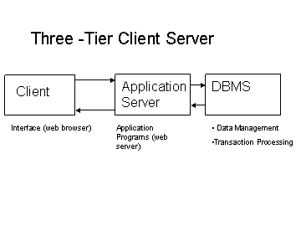
Fig: - Logical three-tier client/server architecture

N-Tier Architecture: -
In N-Tier architecture, the middle tier is allowed to have multiple application objects rather than a single application. Each of these application objects must have a well-defined interface which allows them to contact and communication with one another. An interface actually brings an idea of contract. That is, each object states through its interface that it will accept certain parameters and return a specific set of results.
Application objects use their interfaces to do business processing. With and N-Tier architecture, one can have multiple applications using a common set of business objects across an organization. This promotes the standardization of business practices by creating a single set of business functions for the entire organization to access. If a particular business rule changes, then changes have to be made to only the business object and if need, to its interface also.
Normalization: -

Normalization is a process during which unsatisfactory relation schemas are decomposed by breaking up their attributes into smaller relation schemas that possess desirable properties.
Normalization of data can be looked upon as a process of analyzing the given relation schemas based on their functional dependencies properties of minimizing redundancy, insertion, deletion and update anomalies.

The different Normal Forms present in DBMS are: -

- First Normal Form: - It states that the domains of attributes must include only atomic values and that the value of any attribute in a tuple must be single value from the domain of that attribute. It disallows a set of values, a tuple of values, or a combination of both as an attribute value for a single tuple.
- Second Normal Form: - A relation is said to be in Second Normal Form if it is in 1NF and non-key attributes are fully functionally dependent on the key attribute(s). If the key has more than one attribute (composite key) then no non-key attributes should be functionally dependent upon a part of the key attributes.
- Third Normal Form: - A relation is said to be in Third Normal Form if it is in 2NF and no non-prime attributes of relation R is transitively dependent on the primary key.
- Fourth Normal Form: - Under this, a record type should not contain two or more independent multi-valued facts about an entity. In addition, the record must satisfy third normal form.
- Fifth Normal Form: - It also deals with multi-valued facts. Here, the record must satisfy the fourth normal form.
- Boyce Codd Normal Form: - It a normal form used in database normalization. It is a slightly stronger version of the third normal form (3NF). A table is in Boyce–Codd normal form if and only if for every one of its nontrivial dependencies X → Y, X is a super key—that is, X is either a candidate key or a superset thereof

5.7 CASCADING STYLE SHEET



Cascading Style Sheets (CSS) is a style sheet language used to describe the presentation semantics (the look and formatting) of a document written in a markup language. It’s most common application is to style web pages written in HTML and XHTML, but the language can also be applied to any kind of XML document, including plain XML, SVG and XUL.

CSS defines HOW HTML elements are to be displayed. Styles are normally saved in external .css files. External style sheets enable you to change the appearance and layout of all the pages in a Web site, just by editing one single file! The CSS files referenced in the HTML page.
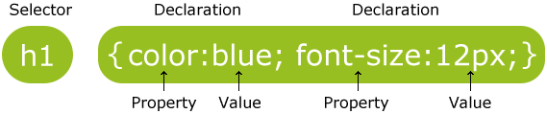
A CSS rule has two main parts: a selector, and one or more declarations:

The selector is normally the HTML element you want to style. Each declaration consists of a property and a value. The property is the style attribute you want to change. Each property has a value.

Following example formats a paragraph in an HTML document
p
{
color:red;
text-align:center;
}
5.8 JAVASCRIPT

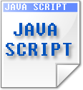

JavaScript was originally developed by Brendan Eich of Netscape under the name Mocha, which was later renamed to LiveScript, and finally to JavaScript.

JavaScript is a prototype-based, object-oriented Scripting Language that is dynamic, weakly typed and has first-class functions. It is also considered a functional programming language because it has closures and supports higher-order functions. JavaScript is primarily used in the form of client-side JavaScript, implemented as part of a web browser in order to provide enhanced user interfaces and dynamic websites.

The primary use of JavaScript is to write functions that are embedded in or included from HTML pages and that interact with the Document Object Model (DOM) of the page. Some simple examples of this usage are:
- Opening or popping up a new window with programmatic control over the size, position, and attributes of the new window (e.g. whether the menus, toolbars, etc. are visible).
- Validating input values of a web form to make sure that they are acceptable before being submitted to the server.
- Changing images as the mouse cursor moves over them: This effect is often used to draw the user's attention to important links displayed as graphical elements.

EXAMPLE:

a) A simple recursive function:

function factorial(n)
{
if (n === 0)
{
return 1;
}
return n * factorial(n - 1);
}

SYSTEM DESIGN

6. SYSTEM DESIGN

6.1 DATABASE SCHEMA DESIGN:

create table otplogin
(
username varchar2(20) not null,
password varchar2(20) not null,logintype varchar2(10)
);

create table otppupil
(
otppupilid varchar2(12) constraint otppidpk primary key,
pupilname varchar2(25) not null,
pupiladdr varchar2(50),
pupilph varchar2(12),
pupilemail varchar2(30),
pupilclass varchar2(20)
);

create table otptutor
(
tutorid varchar2(12) constraint otptidpk primary key,
tutorname varchar2(25) not null,
tutoraddr varchar2(50),
tutorph varchar2(12),
tutoremail varchar2(30),
tutorgender varchar2(6),
tutorqualification varchar2(20),
tutorexperience number(2),
tutorspecialization varchar2(20)
);

create table otpsessionrequest
(
otprequestid varchar2(12) constraint otpreqidpk primary key,
otprequestdate date,
otppupilid varchar2(12) references otppupil(otppupilid),
otprequestsubject varchar2(40),servicestatus varchar2(20)
);

create table otpsessionmapping
(
otprequestid varchar2(12) references
otpsessionrequest(otprequestid),
tutorid varchar2(12) references otptutor(tutorid)
);

create table otpfeedback
(
feedbackid varchar2(12) constraint otpfidpk primary key,
pupilid varchar2(12) references otppupil(otppupilid),
tutorid varchar2(12) references otptutor(tutorid),
feedbackdate date,
description varchar2(200)
);

6.2 DATA DICTIONARY

-----------------------------------------------------------------------------------------------------------
Primary Key Constraints Used
-----------------------------------------------------------------------------------------------------------
Primary Key Name Table Name Column Name

otppidpk otppupil pupilid

otptidpk otptutor tutorid

otpreqidpk otpsessionrequest requestid

otpfidpk otpfeedback feedbackid

-----------------------------------------------------------------------------------------------------------
Sequences Used
-----------------------------------------------------------------------------------------------------------
create sequence otppupilidseq increment by 1 start with 101 minvalue 101 nocycle;

create sequence otptutoridseq increment by 1 start with 101 minvalue 101 nocycle;

create sequence otprequestidseq increment by 1 start with 101 minvalue 101 nocycle;

create sequence otpfeedidseq increment by 1 start with 101 minvalue 101 nocycle;

6.3 DATA FLOW DIAGRAM

A data-flow diagram (DFD) is a graphical representation of the "flow" of data through an information system. DFDs can also be used for the visualization of data processing (structured design).
On a DFD, data items flow from an external data source or an internal data store to an internal data store or an external data sink, via an internal process.
A DFD provides no information about the timing or ordering of processes, or about whether processes will operate in sequence or in parallel. It is therefore quite different from a flowchart, which shows the flow of control through an algorithm, allowing a reader to determine what operations will be performed, in what order, and under what circumstances, but not what kinds of data will be input to and output from the system, nor where the data will come from and go to, nor where the data will be stored (all of which are shown on a DFD)

Larry Constantine first developed the DFD as a way of expressing system requirements in a graphical form, this lead to modular design.
A DFD is known as a “bubble chart” has the purpose of clarifying system requirements and identifying major transformation they will become program in system design. So it is the starting point of the design to lowest level of details. A DFD consists of series of bubbles joined by data flows in the system.

DFD Symbols
In DFD, there are four Symbols
- A square-defines a source or destination system data
- An arrow identified data flow. Its is the pipeline through which the information flow
- A circle or a bubble represents a process that transforms
- Incoming data flow into outgoing data flows
- An open rectangle is a data source, data at rest or a temporary of data

Process that transforms data flow

Source or destination of the data

Data flow

Process for data store.

CONTEXT LEVEL :
Database
OTP
Enter Details Store Data
User

Retrieve Data

LEVEL 1 :

Login
User
Enter Details Verifying
Login

OTP

TUTORS
PUPILS
SESSIONS
FEEDBACK

Storing

Database
LEVEL 2 :

Enter details Verifying
Login
OTP

User
Login
TUTORS
PUPILS
FEEDBACK
SESSIONS
Stock

Login

Insert Insert Insert View

Store Store Store Store

FEEDBACK
REPORTS
PUPILS
TOVVFGGF

6.4 ER DIAGRAM
name
ID
I
Dip

Phonne
addr
Pupil
Avails
Pays
rate
Type
Service ID
name
ID
Address
Name
Bill Date
Bill amt
Bill ID
provides
Adds
approves
Nannamemnae
Tutor
Admin
Sessions
Billing

SYSTEM TESTING
7. TESTING

7.1 CODING , TESTING AND IMPLEMENTATION

The main interfaces are:

- Web server and application server interface.
- Application server and Database server interface.

Check if all the interactions between these servers are executed properly. Errors are handled properly. If database or web server returns any error message for any query by application server then application server should catch and display these error messages appropriately to users. Check what happens if user interrupts any transaction in-between? Check what happens if connection to web server is reset in between?

7.2 TESTING AND ERRORS

Compatibility of our web site is very important testing aspect. See which compatibility test to be executed:

- Browser compatibility
- Operating system compatibility
- Mobile browsing
- Printing options

Browser compatibility:

Some applications are very dependent on browsers. Different browsers have different configurations and settings that your web page should be compatible with. Your web site coding should be cross browser platform compatible. If you are using java scripts or AJAX calls for UI functionality, performing security checks or validations then give more stress on browser compatibility testing of your web application. Test web application on different browsers like Internet explorer, Firefox, Netscape navigator, AOL, Safari, Opera, Chrome browsers with different versions.

OS compatibility:

Some functionality in your web application is may not be compatible with all operating systems. All new technologies used in web development like graphics designs, interface calls like different API’s may not be available in all Operating Systems.
Test your web application on different operating systems like Windows, Unix, MAC, Linux, Solaris with different OS flavors.

7.3 SAMPLE TEST CASES DONE

Sl.No. | Test Case Done | Action taken
1 | Invalid user credentials entered | Redirected to error page. Customer of Admin main page not shown.
2 | Incomplete form entry in the registration and few other pages. | Users are prompted to complete the page to proceed next.
3 | Illegal data entry. E.g., amount entered in negative values. Phone numbers out of range, etc., | All such errors are captured and prompted accordingly so that users will provide only the legal input to the system.
4 | Invalid Credit card number entry. | Captured and prompted the user to enter only the valid card number.
5 | Incorrect Booking ID entry | Error message notified to the user for entering the correct booking ID.

SCREENSHOTS

8.SCREENS
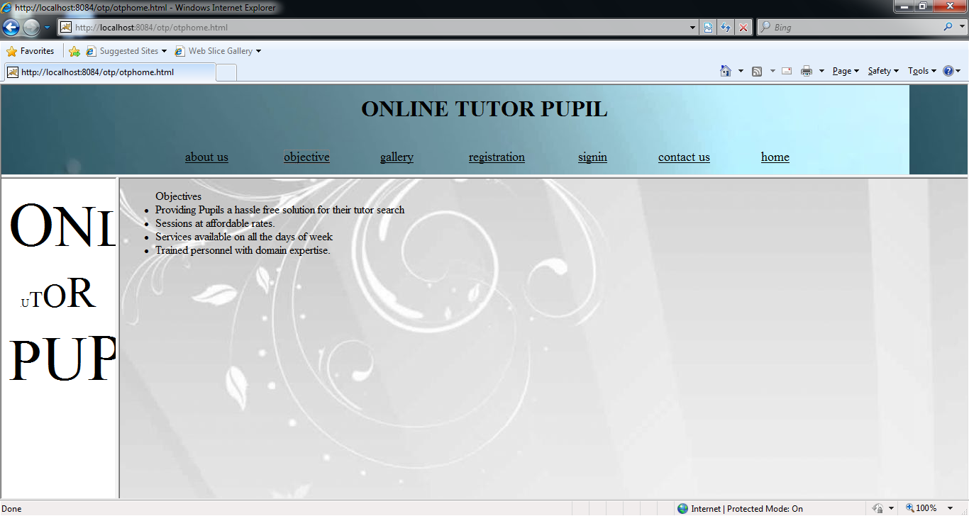

Fig.8.1 OTP main page

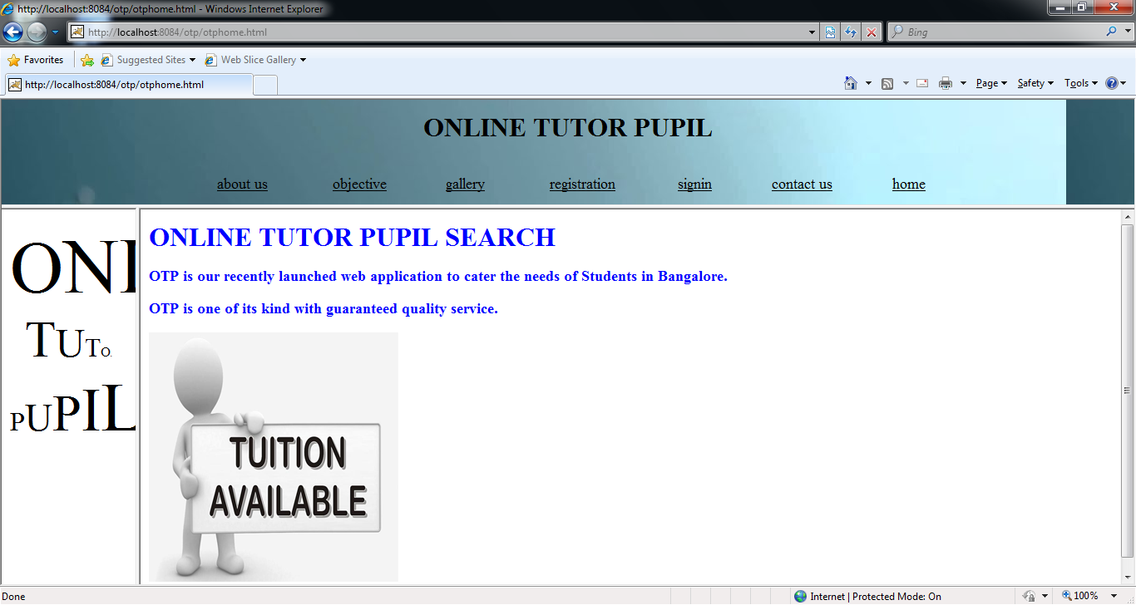
Fig.8.2 OTP Search

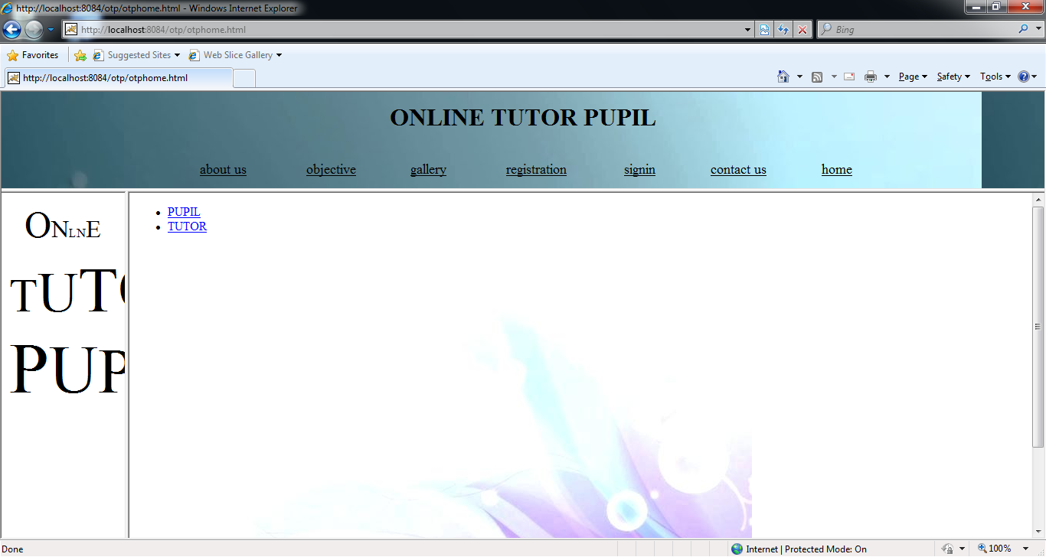
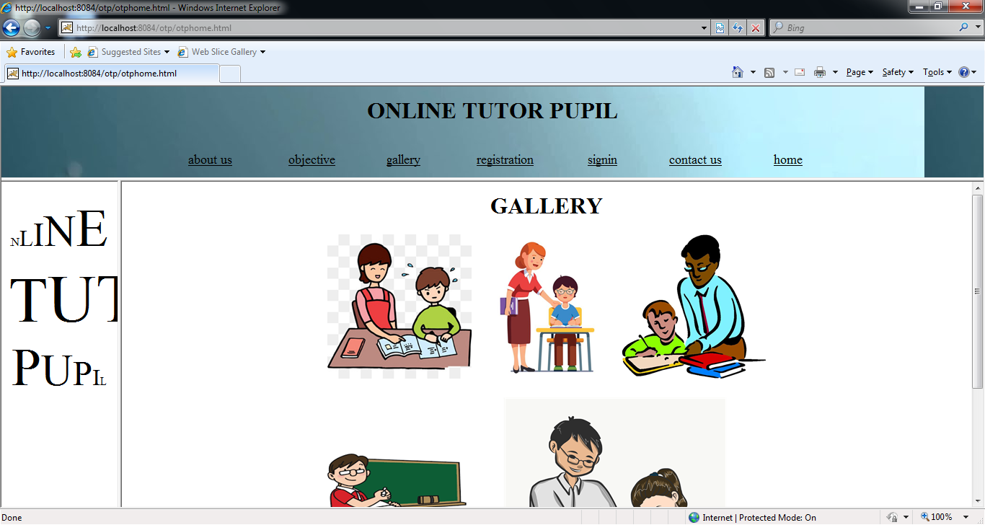
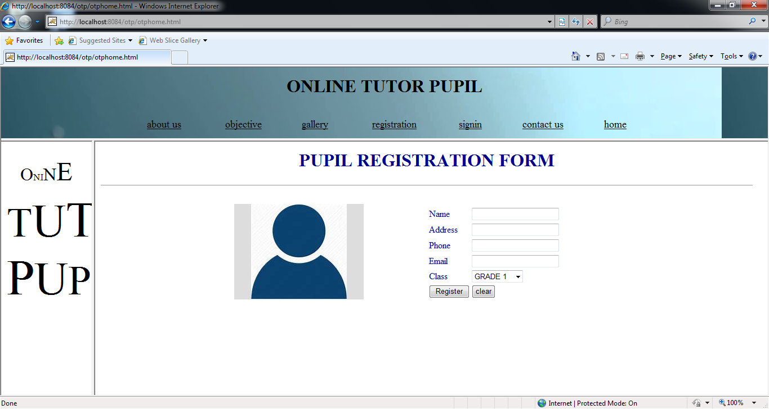
Fig.8.3 OTP Gallery
Fig. 8.4 OTP Signin
Fig. 8.5 OTP Registration

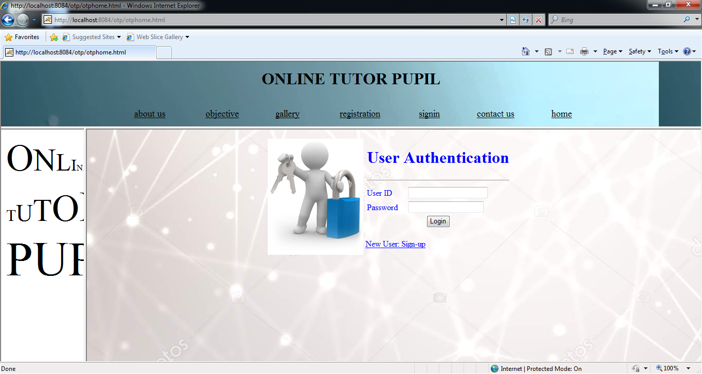

Fig 8.6 OTP Authentication

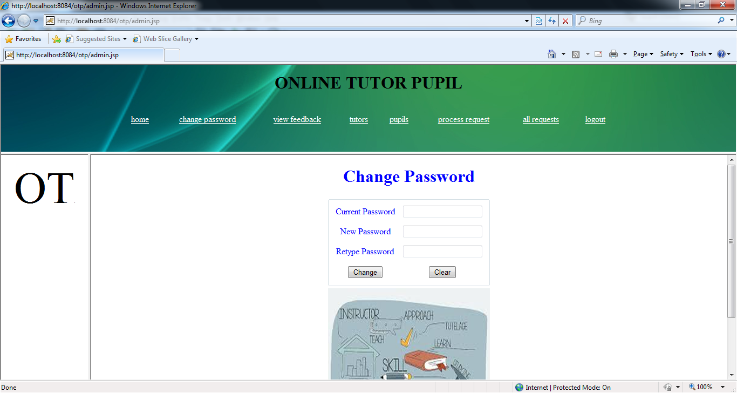
Fig 8.7 OTP Changing Passward

CODING

9. SAMPLE CODES

<!DOCTYPE html>
<html>
<head>
<title></title>
<meta http-equiv="Content-Type" content="text/html; charset=UTF-8">
<style type="text/css">
body
{
}
A
{
color: blue;
}</style>
</head>
<body>
<ul>
<li><a href="pupilregistration.html">PUPIL</a></li>
<li><a href="tutorregistration.html">TUTOR</a></li>
</ul>
<img src="bg4.jpg" /></body>
ss </html>
<!DOCTYPE html>
<html>
<head>
<title></title>
<meta http-equiv="Content-Type" content="text/html; charset=UTF-8">
<script type="text/javascript">
function checkForEmpty(form){
cn = document.regform.mname.value;
caddr = document.regform.maddress.value;
phno = document.regform.mphone.value;

function checkPhno()
{
var retval = true;
var pno = document.regform.mphone.value;
var stripped = pno.replace(/[\(\)\.\-\ ]/g, '');
//strip out acceptable non-numeric characters
if (isNaN(parseInt(stripped))) {
alert("The phone number contains illegal characters.");
document.regform.mphone.value="";
retval = false;
}
if(pno.length != 10)
{
alert("Illegal length");
document.regform.mphone.value="";
retval = false;
}
return retval;
}
function emailValid()
{
var aemail = document.regform.memail.value;
//if email field is empty - warning displays and return false
if(aemail=="")
{
alert ("This field is required. Please enter email myemail@mysite.com")
return false
}
//get email string length
len = aemail.length
//check position of @ character.
//it may be anywhere but not in the beginning or at the end of string.
if((aemail.charAt(1)=='@')||(aemail.charAt(1)=='.'))
{
return isValid(parm,num,lwr+upr);
}
function isValid(parm,num,val) {
if (parm == "")
{
alert("Please enter text");
return false;
}
for (i=0; i<parm.length; i++) {
if (val.indexOf(parm.charAt(i),0) == -1)
{
alert("please enter only alphabet");
if(num==1)
document.regform.mname.value="";
return false;
}
}
return true;
}
function checkfill()
{
var ele;
var flag=true;
var ecount=document.regform.elements.length;
for(i=0;i<ecount;i++)
{
ele=document.regform.elements[i].value;
if(ele.length==0)
{
window.alert("Please fill all fields");
flag=false;
break;
}
<td><input type="text" name="usbaddress" value=""/>
</td></tr>
<tr> <td>Phone</td>
<td><input type="text" name="usbphone" value="" onblur="checkPhno()" />
</td></tr>
<tr> <td>Email</td>
<td><input type="text" name="usbemail" value="" onblur="emailValid()"/>
</td></tr>
<tr> <td>Class</td>
<td>
<select name="stuclass">
<option value="I Std">GRADE 1</option>
<option value="II Std">GRADE 2</option>
<option value="III Std">GRADE 3</option>
<option value="IV Std">GRADE 4</option>
<option value="V Std">GRADE 5</option>
<option value="VI Std">GRADE 6</option>
<option value="VII Std">GRADE 7</option>
<option value="VIII Std">GRADE 8</option>
<option value="IX Std">GRADE 9</option>
<option value="X Std">GRADE 10</option>
<option value="XI Std">GRADE 11</option>
<option value="XXI Std">GRADE 12</option>
</select>
</td><
</td>
</tr>
</table>
</tr>
</table>
</form>
</center>
</table>
</form>
<a href="registration.html">New User: Sign-up</a>
</td>
</tr>
</table>
</center>
</body>
</html>
<%@page contentType="text/html" pageEncoding="UTF-8"%>
<%@page import = "java.sql.*" %>
<!DOCTYPE html>
<html>
<head>
<meta http-equiv="Content-Type" content="text/html; charset=UTF-8">
<title>JSP Page</title>
</head>
<body>
<%
Connection c = null;
ResultSet r = null;
Statement s = null;
boolean f = false;
String un = request.getParameter("uname");
String pw = request.getParameter("pwd");
String ut = "";
try
{
Class.forName("sun.jdbc.odbc.JdbcOdbcDriver");
c = DriverManager.getConnection("jdbc:odbc:otpdsn","scott","tiger");
s = c.createStatement();
while(r.next())
{
f = true;
setAttribute("uid",.getString(1))r.==true).sendRedirect("admin.jsp")}if(ut.equals("pupil"))
{
return(newpassword);
}
package otppack;
import java.sql.DriverManager;
import java.sql.Connection;
import java.sql.ResultSet;
import java.sql.Statement;
/** public ResultSet getReport(String querystr
{
rs = rb.getReport("select * from otpfeedback");
while(rs.next())
{
feedid = rs.getString(1);
pupil = rs.getString(2);
tutor = rs.getString(3);
date = rs.getString(4);
message = rs.getString(5);
%>
<tr>
<td><%= feedid %></td>
<td align="center"><%= pupil %></td>
<td align="center"><%= message %></td>
</tr>
<% }
}
catch(Exception e)
{
%> <%= e %>
<% }
%>
</table>
</center>
</body>
</html>

CONCLUSION AND FUTURE ENHANCEMENTS

10. CONCLUSION AND FUTURE ENHANCEMENTS

CONCLUSION:

This web application is easy to use and user-friendly software. End-users are expected to have some experience in using windows applications and browsing the Internet. Order tracking is a very useful module in this application. Clients can get appropriate information with less efforts and time.

FUTURE ENHANCEMENTS:

- Session Request can be made through SMS.
- Session Pooling can be attained so as to reduce the burden on individual Pupil.
- Live session through Video conferencing and be made.
Etc.,

BIBLIOGRAPHY
11. BIBLIOGRAPHY

  - Books Referred:

- Software Engineering by Roger Pressman
- Beginning JSP – Wrox Publication
- Database Systems by Abraham Silberschatz
- Oracle 10g by Gary Cornell and Horstman.

  - Websites referred:

- www.google.com
- www.w3schools.com/html
- www.htmlcodetutorial.com/
- http://en.wikipedia.org

